 **COMSATS University Islamabad, Lahore Campus**

**MidTerm Examination – Semester Spring 2024**

|  |  |  |  |  |  |  |  |  |  |  |  |  |  |  |
| --- | --- | --- | --- | --- | --- | --- | --- | --- | --- | --- | --- | --- | --- | --- |
| Course Title: | Web Technologies | | | | | | | Course Code: | | | CSC339 | | Credit Hours: | 4(3,1) |
| Course Instructor/s: | SHUJA AKBAR | | | | Programme Name: | | | | BS(CS) | | | | | |
| Semester: |  | Batch: | FA-BSE-A,B | Section: | G1 | | | | Date | | | 02 April 2, 2024 | | |
| **Time Allowed:** | **1.5 Hours** | | | | | **Maximum Marks:** | | | | | | **25** | | |
| Student’s Name: |  | | | | | | Reg. No. | | |  | | | | |
| **Important Instructions / Guidelines:**   * **All parts are compulsory.** **Please return the question paper.** | | | | | | | | | | | | | | |

**Question No 1. *CLO: <3>; Bloom Taxonomy Level: <Applying>*** **[10]**

DOM manipulation using Javascript.

Create an input field with id 'inputField', Add button with 'addButton' id and a div with id 'target'.

When the user enters text in the inputField and presses the Add button. An unordered list in the 'target' div is appended.

Hint:

Create a function that should read the value from the text field and append the list items on click event.

**Question No 2. *CLO: <3>; Bloom Taxonomy Level: <Applying>*** **[10]**

Create a dropdown selection box for ID range 1 to 10. On change event send request AJAX xhttp request using JQUERY to fetch data from the endpoint provided below. Update the content of a div with ID “comments” accordingly.

[https://jsonplaceholder.typicode.com/comments?postId=[id](https://jsonplaceholder.typicode.com/comments?postId=%5bid)]

SAMPLE OUTPUT

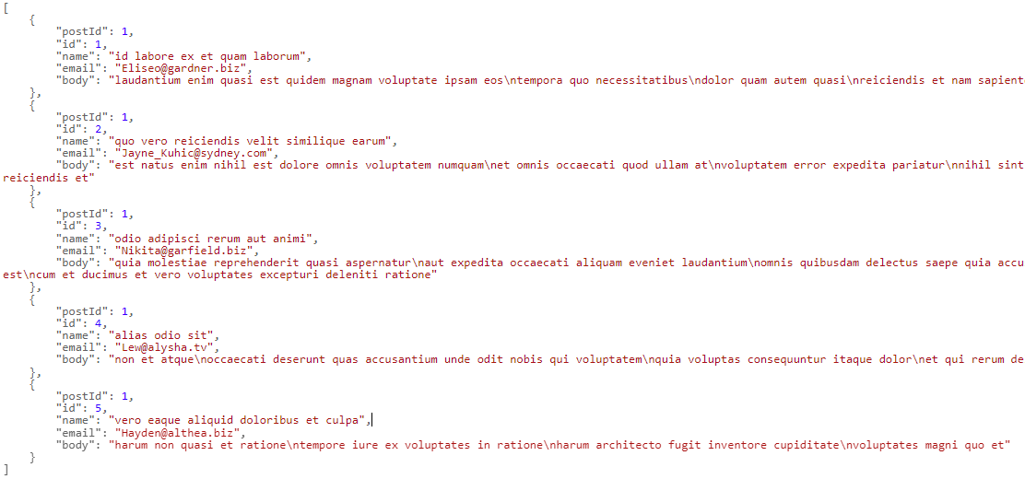

**Question No 3. *CLO: <3>; Bloom Taxonomy Level: <Applying>*** **[5]**

Your web page should be responsive on different screen sizes. Use Bootstrap to design your page accordingly.